

Name: Eshan Kalp Trivedi

**BatchD**2

**Roll No.:** 16010221038

**Experiment / assignment / tutorial No. 5**

**Grade: AA / AB / BB / BC / CC / CD /DD**

**Signature of the Staff In-charge with date**

**TITLE:** Program to sort array

**AIM:** Program to sort the 1D array in the ascending or descending order and then accept the element from user and insert in the same array at its correct place by keeping array sorted

### Expected OUTCOME of Experiment:

To show and explain the use of derived and structured datatypes such as arrays, structures and unions.

### Books/ Journals/ Websites referred:

1. Programming in C, second edition, Pradeep Dey and Manas Ghosh, Oxford University Press.
2. Programming in ANSI C, fifth edition, E Balagurusamy, Tata McGraw Hill.
3. Introduction to programming and problem solving, G. Michael Schneider

,Wiley India edition.

1. [**http://cse.iitkgp.ac.in/~rkumar/pds-vlab/**](http://cse.iitkgp.ac.in/~rkumar/pds-vlab/)

**Problem Definition:**

The program takes a 1D array and sorts it in the specified manner. The user enters an element and the same has to be inserted at the correct place in the sorted array.





A1

i=0

# Flowchart:

START



PRINT enter number of

elements

INPUT a

PRINT enter elements

F

i<a-1

T

j=i+1

F

j<a

T

b=num[i]

num[i]=num[j]

num[j]=b

j=j+1

i=i+1

i=0





F

i>=0

T

F If

num[i]>a1

T

b=num[i]

num[i+1]=b

num[i]=a1

F

i<=a

T

**Department of Science and Humanities**

i=i+1

i=0

i=i-1



A1

F

I<a

T

PRINT num[i]

PRINT enter new

element

i=a

i=i+1



PRINT num[i]



A1

A1

STOP



**Implementation details:**

#include<stdio.h> void main()

{

printf("Enter the size of the array\n"); int n;

scanf("%d",&n); int a[n];

printf("Enter the elements of the array\n"); int i;

for(i=0;i<n;i++)

{

scanf("%d",&a[i]);

}

int j; int t=0;

for(i=0;i<n-1;i++)

{

for(j=i+1;j<n;j++)

{

if(a[i]>a[j])

{

t=a[i]; a[i]=a[j]; a[j]=t;

}

}

}

printf("\n");

printf("The sorted array is- \n"); for(i=0;i<n;i++)

{

printf("%d\n",a[i]);

}

printf("Enter the value to be inserted\n"); int m;

scanf("%d",&m);

printf("\n");

printf("The array after insertion is-\n"); if(a[0]>=m)

{

printf("%d\n",m);



for(i=0;i<n;i++)

{

printf("%d\n",a[i]);

}

}

else if(a[n-1]<=m)

{

for(i=0;i<n;i++)

{

printf("%d\n",a[i]);

}

printf("%d\n",m);

}

else

{

for(i=0;i<n-1;i++)

{

printf("%d\n",a[i]); if(m>a[i] && m<a[i+1])

{

printf("%d\n",m);

}

}

}

printf("%d",a[i]);

}

**Output(s):**

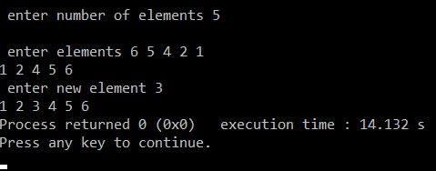



**Conclusion:**

Taking an input form the user for an array and sorting it in a logical order and displaying the array properly was learnt.

# Post Lab Descriptive Questions

Write a program to enter n numbers, store them in an array and rearrange array in the reverse order.

## #include <stdio.h> int main()

{

int i,n,a[100];

printf("\n\nRead n number of values in an array and display it in reverse order:\n");

printf("

\n");

printf("Input the number of elements to store in the array:\t"); scanf("%d",&n);

printf("\nInput %d number of elements in the array :\n",n); for(i=0;i<n;i++)

{

printf("element %d : ",i);

scanf("%d",&a[i]);

}

printf("\nThe values store into the array are : \n"); for(i=0;i<n;i++)

{

printf("% 5d",a[i]);

}

printf("\n\nThe values store into the array in reverse are :\n"); for(i=n-1;i>=0;i--)

{

printf("% 5d",a[i]);

}

printf("\n\n");

}



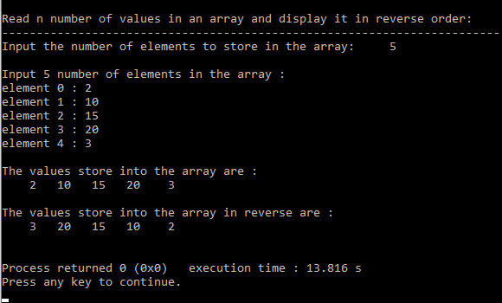

### Date: Signature of faculty in-charge